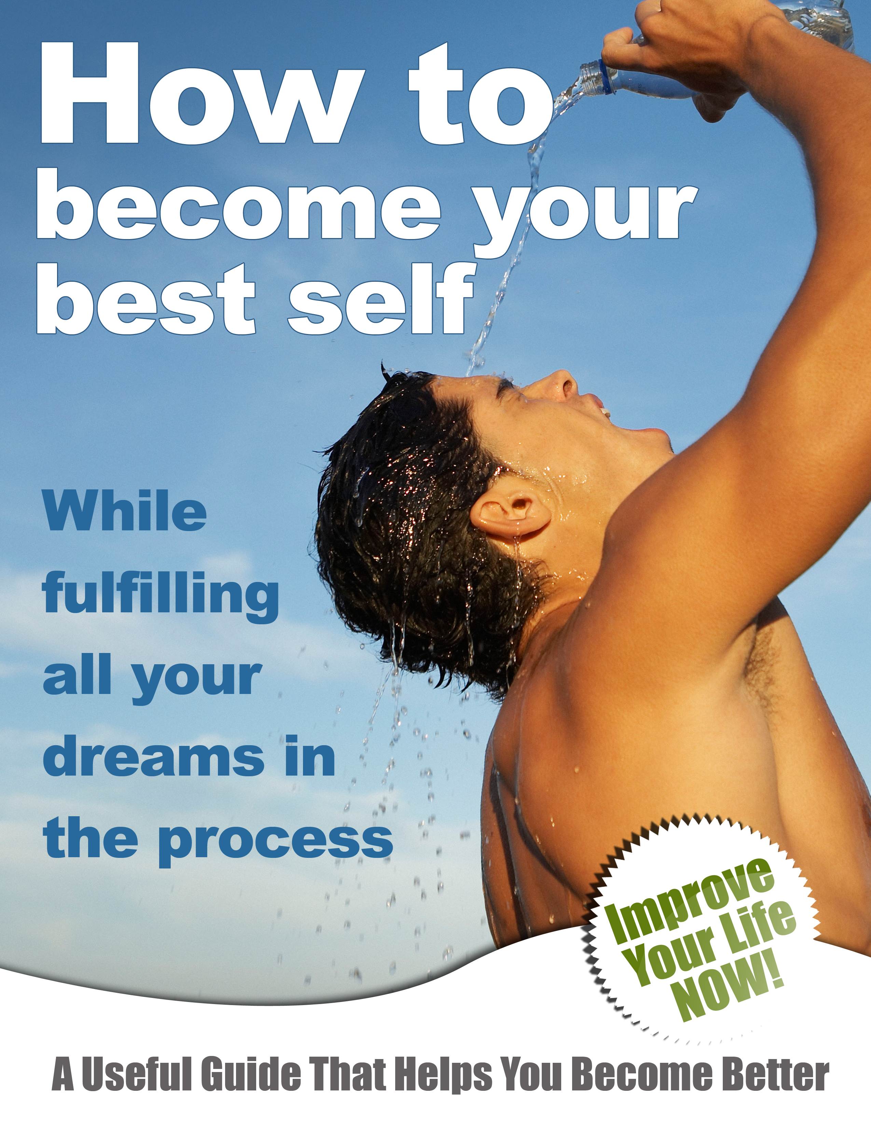

Contents

Chapter 1: How the World Really Works 5
Successful People are Lucky 7
Your Problems Are Other People’s Fault 7
Rich People Are Either Greedy or Were Born that Way 7
You Are Who You Are, You Can’t Change 8
Chapter 2: Harness the Astounding Power of Thought 8
Visual Thought Exercise 11
Auditory Thought Exercise 11
Tactile Thought Exercise 12
Chapter 3: Know and Become Who You Really Are 13
Other People’s Opinions 14
Your Weaknesses and Doubts 14
Your Current Results 15
Decide What YOU Really Want 16
Decide What You’re Going to Give in Return for It 16
Write Out a Plan of Action 17
Start Taking Action NOW 18
Chapter 4: Master Your Mindset 18
To Teach 19
To Test 19
To Motivate 19
Chapter 5: Conditioning Your Mindset for Your Ideal Body 20
Value Your Body 21
Acknowledge Your Mortality 22
Learn About Your Body 22
Chapter 6: The Three Biggest Secrets to Getting What You Want 23
Focus-Focus-Focus 23
Never Stop Learning 24
Recommended Reading 25
Mind Movies 25

Dear Reader,
Congratulations on taking a proactive step towards living the life you’ve always wanted. What you’re about to learn are the secrets of success which most people NEVER discover in their lifetime.
Of course, you’re probably curious as to how you’ve managed to come by this information in a simple ebook. If this information is so powerful, why isn't everybody talking about it?
The answer is simple…
Because most people are too busy voicing their own opinions about how life should be lived, and not enough people are willing to take the time to listen. What you’re about to read is not being taught in schools, so most people grow up assuming that their conventional education is all that they need to get by in life.
When they find that something isn’t working, they continue to apply this same strategy hoping that one day they'll get “lucky” and produce a different result. Either that or they blame some other person or exterior circumstance and thus continue to hang on to the beliefs which are actually causing them to take actions that aren’t getting them what they want.
It’s also typical of human beings to hang onto beliefs long after they have outlived their usefulness. Many people grow up in circumstances which cause them to develop irrational beliefs or defense mechanisms. However, once those circumstances have passed for their life, that person is left hanging on to the beliefs and behaviors which got them by for a time, but which are no longer useful in their new environment.
So believe it or not, in spite of the fact that this book is free most people will never benefit from the information in it for one reason: they don't believe that they need it. They're not actively seeking a solution because of the belief that what they already know is enough.
Thankfully, you've reached a point in your life where you’re hungry for more than just the traditional knowledge about what it takes to be successful. You've probably heard it said that people who get exactly what they want out of life are either ridiculously rich, uncannily lucky, or both.
But as you're about to discover in reading this book, getting what you want has nothing to do with how much money you have or how “lucky” you are. The sooner you accept this, the sooner you can put the genuine secrets of success into practice.
And believe me, when you do, you’ll have everybody telling you how lucky you are.
Enjoy.

Chapter 1: How the World Really Works
Everything that you “know” about living your life your way is probably wrong, and that's okay. After all, you can only go by the things that you've learned in your experience and education. You probably went to school just like every other person on the planet and learned the basic ABC's and 123’s, a little bit about history, a little bit about art, and a little bit about a couple of other things you probably can't even remember.
You probably learned how to pass the tests and to please your teacher and parents, but you might not have the slightest idea as to how to really please yourself. You probably learned how to stay out of trouble with the authorities at your school, but might not have learned the principles of persuasion, influence and leadership.
You might have learned a little bit about the human body, but what you learned probably didn’t help you to gain a healthy body. You probably studied about the great people of history, but you probably never learned how to live by the principles which made great.
Most important, you probably learned how to count money and to make change, but chances are you don't know as much as you’d like to about earning good money and building wealth.
In other words, what you learned in school did little to help you understand how the world really works.
Sound impossible?
Let's look at a few statistics:
Less than 20% of the world’s population controls over 80% of the wealth.
The majority of individuals living in highly industrialized societies are either overweight or obese.
The majority of people living in North America are living paycheck to paycheck…and that’s one of the wealthiest areas of the world.
This is not to mention the nearly astronomical amount of consumer debt that plagues most working and middle-class people.
Now let's take an honest look at the circumstances of your life: do you have the relationships you really want?
Are you satisfied with your level of self confidence and inner peace?
Do you make enough money to have a reasonable amount of financial security and to buy the things you want?
Are you satisfied with the condition of your physical health?
And most important:
If you were to die tomorrow, what kind of a legacy would you leave behind in the hearts and minds of the people you love most?
If any of the above questions caused an unsettled feeling in your heart, a sense of dissatisfaction, shame or even guilt, then one thing is certain:
The rules which you learned to live your life according to aren’t producing the results you really want.
As depressing as this might seem, it's actually a very good place to start when it comes to fulfilling your dreams and becoming your best self.
Why is this?
Because dissatisfaction presents you with an opportunity to change your approach and thus to get the results you really want. But this starts with accepting the fact that the way the world works is different than what you might now believe. If this were not true, you’d probably be a whole lot more satisfied with your life and have more of what you really want.
So now that we have that out of the way, let’s look at a few of the popular myths which keep people from getting what they really want:

Successful People are Lucky
There's no doubt that chance plays a role in all of our lives. There’s no doubt that sometimes bad things happen to good people and that good things happen to bad people. But it's also true that billions of people go through their lives tolerating poverty, poor relationships and poor health because of something they call “bad luck.”
In his best-selling book “Think and Grow Rich,” author Napoleon Hill wrote about a series of experiments which was done to determine how “lucky” people got that way.
The results of the experiment proved that lucky people were simply those who remembered the good things that had happened to them and who focused on what they really wanted.
On the other hand, people with “bad luck” remembered mostly the bad things that had happened to them and focused on what they didn’t want.
As you’re about to learn, this alone is the most important difference between people who get what they want and people who don't get what they want.

Your Problems Are Other People’s Fault
Most people who don’t have what they want out of life will be quick to tell you exactly who or what caused their life to turn out that way. In other words, most people see themselves as victims of either circumstances or the choices of others, and thus neglect their own power to assert control over their own life.
Again, there is no doubt that chance plays a role in all of our lives and that we’re sometimes directly or indirectly affected by the choices of others. But the most successful people in the world acknowledge that no matter what happens to them, they are always in control of who they decide to become as a result.
And that makes all the difference.

Rich People Are Either Greedy or Were Born that Way
This is probably the leading cause of poverty and financial misfortune. Believing that rich people are greedy makes it almost certain that you will never become rich yourself. After all, who wants to be seen as a greedy person? Not to mention that this belief will also keep you from seeking advice from wealthy people about how to make money and build wealth.
Instead, you'll end up doing what the majority of people do: they take financial advice from other broke people and wonder why they stay broke. The belief that rich people were “born that way” is just as crippling. Over 80% of the millionaires in North America are first-generation rich. That means they built their wealth out of nothing.
There’s no reason why you can’t do the same. But first you have to let go of the myth that rich people have to be either greedy or born that way.

You Are Who You Are, You Can’t Change
There’s no doubt that genetics plays a role in our development and in our capabilities to perform certain duties in life. But there are also a lot of people who believe that they were born the way they are and that there's nothing they can do to change. For example, many people are shy or passive and believe that it's just the way they are.
The same is true with people's beliefs about their degree of willpower, self-reliance, creativity, discipline, assertiveness and many other character traits. Many people have problems with anger, poor health, low self-esteem, procrastination or timidity and believe that they are that way because of their parents, their nationality, their cultural upbringing and a whole slew of other things.
In reality, all of these character traits are a result of habits which a person has formed by a lifetime of repeated choices. Once these choices become a habit, people develop the crippling belief that these habits are no longer choices.
Your life and your habits are not products of your genetics or your circumstances; they are the product of your choices. And you’re about to learn how to start making the choices which will make all the difference in living your life your way.

Chapter 2: Harness the Astounding Power of Thought
Have you ever given any thought as to just how powerful your thoughts are? Most people never do because of the fact that their thoughts aren’t something they can reach out and grab a hold of. Most people believe that because of the fact that their thoughts occur in the privacy of their own mind, that they have no bearing on the reality of their outer life.
As a result of this, many people greatly underestimate the power of their thoughts and thus never bother to learn how to control and focus their thoughts towards getting what they really want.
But the mind is an interesting place… it's a lot like a plot of land. If you don't make a proactive effort to plant and to nurture the seeds which will bring forth the kinds of plants you want, you’ll end up with a lot of things that you don’t want.
Most people's minds are full of negative and disempowering thoughts, not because they've chosen these thoughts, but because they've neglected to choose more empowering ones.
And where did these negative thoughts come from? Just look to the contents of the previous chapter and it becomes very clear. Your thoughts are a direct result of your past experiences, education and conditioning.
And it’s these thoughts which influence your beliefs about how the world works, and those beliefs affect your interactions with the world. These interactions include: your relationships, your efforts to earn money and build wealth, your eating habits, your physical activities, and hundreds of other things which produce the results that make up your lifestyle.
Considering this, it's probably a good idea to give a second thought to just how important your thoughts are. Just imagine what kind of results you could produce in your life if you could begin to choose different thoughts that would build different beliefs about how the world works. Beliefs which would inspire different actions and get different results.
Results that you REALLY want.
And how can you choose thoughts which will lead to results that you really want? You begin by choosing thoughts which are consistent with what you really want. Now in case you believe you're doing this already, here's something to think about:
Most people have a much stronger idea of what they DON”T want, than what they do want. Just ask anyone what they really want from their job, their relationships, their financial life and their health. Chances are, they’ll rattle off a lot of things that that they don’t want.
This is because they’re always thinking about what they don't want. These thoughts are what influence their beliefs about how the world works. These beliefs affect their actions and those actions produce results which are consistent with the seeds which led to those actions: their thoughts.
Thoughts=Beliefs=Actions=Results
Now, here’s a question to ask yourself:
What kinds of results are you going to continue to get in your life if your thinking never changes? All you have to do is look at the results you're getting, and there's your answer.
If you’re ready to change this, then let’s look at how your thoughts are produced and what you can do to begin to change them.
First of all, there are three kinds of thoughts: thought pictures (visual), “spoken” thought (auditory) ,and thoughts that you “act out” in your head (tactile).
For example:
Picture an elephant…that's a visual thought.
Read these words without speaking them aloud…that’s an auditory thought.
Picture yourself driving your car…that’s a tactile thought.
These are all thoughts which influence your external behaviors: the things you notice most easily, the words you speak, and the actions you take. These are all behaviors which can be changed by choosing different visual, auditory and tactile thoughts.
How is this possible?
It begins with understanding that the brain is a physical body part. There’s nothing magical or spiritual about the brain or it’s development. Just as you can condition other parts of your body through repetitious exercise, you can also condition your brain.
And just like physical exercise, when you first begin to condition your brain it will seem like an impossible task. Just think about the first time you tried to run a mile, or lift weights, or do some other kind of physical exercise which you’d never done before.
At first, it might have seemed impossible. You probably even wanted to give up. But if you stuck with it, you probably found that it got easier and easier, until it became second nature.
A good example of this is when you learned to walk, talk or read. And just think about how easy those things are to you now. So as we look at a few exercises for conditioning your brain, remember that these are going to take some work and that they'll seem almost impossible at first.
But with enough practice you'll develop the natural habit of choosing thoughts that you really want. These thoughts will become beliefs, these beliefs will inspire actions and those actions will produce results which are consistent with what you really want.

Visual Thought Exercise
Get a poster board and start collecting pictures of things that you really want. You can find these pictures on the Internet, in magazines, and many other places. With these, you're going to create a “vision board.” In addition to the pictures of what you really want, put a few pictures of yourself on your vision board as well.
This way you’re actually training your mind to see yourself and the things you really want as part of the same picture. Put your vision board somewhere that you can see it every day, and make sure that you spend some time looking at it. With enough repetition, you'll begin to find that these images will become the dominating “thought pictures” in your mind.
You'll also begin to notice things throughout the day which are consistent with the things you really want. After enough practice, these new thoughts will begin to influence your actions and produce new results.

Auditory Thought Exercise
Sit down right now and write down three thoughts which are consistent with what you really want out of life. The best way to do this is to ask yourself which character traits you’ll need to produce the results you really want. Once you’ve identified these characteristics, write them down somewhere that you can access them every day.
These are spoken affirmations which will help you to make your “spoken” thoughts consistent with who you must become in order to get what you really want.
Here are a few examples:
If you want to start your own business or land a better career:
“I am creative, self-reliant and persuasive.”
If you want to discipline yourself to take better care of your body:
“I am disciplined and self-reliant.”
If you want better relationships:
“I am funny, friendly and compassionate.”
Now in order for this exercise to work, you have to do it every day. For best results, speak each of your affirmations out loud in the morning and in the evening. Just like your vision board exercise, this exercise will begin to change your auditory thoughts according to what you really want. Those thoughts will change your beliefs, and those beliefs will produce actions which are consistent with who you must become to get what you want.
Now, you might notice that all of these affirmations have one thing in common: they’re primarily focused on who you must become to get what you want.
Sure, you can also write out some that say things like:
“I’m healthy, thin, financially secure and I have great relationships.”
But if you focus instead on the characteristics and habits which will make you healthy, thin, financially secure and a great friend/partner, the results will naturally follow.

